ISD TERM PROJECT
Software Requirements Specification

E-GOVERNANCE TRANSPARENCY DASHBOARD



Group ID: VI
Student Registration No: L1F23BSCS0273
Student Name :MUHAMMAD HAMZA IMTIAZ
Faculty of Information Technology
University of Central Punjab

Table of Contents iii
List of Figures v
List of Tables vi
Revision History vii
1. Introduction and Background 1
1.1 Product (Problem Statement) 1
1.2 Background 1
1.3 Scope 1
1.4 Objective(s)/Aim(s)/Target(s) 1
1.5 Challenges 1
1.6 Learning Outcomes 1
1.7 Nature of End Product 1
1.8 Completeness Criteria 1
1.9 Business Goals 1
1.10 Related Work/ Literature Survey/ Literature Review 1
1.11 Document Conventions 1
2. Overall Description 2
2.1 Product Features 2
2.2 User Classes and Characteristics 2
2.3 Operating Environment 2
2.4 Design and Implementation Constraints 2
2.5 Assumptions and Dependencies 2
3. Project Management. 3
3.1 Work Breakdown Structure (WBS). 3
3.2 Create Milestone table 3
3.3 Develop an Activity Graph. 3
3.4 Find the Critical Path. 3
3.5 Create a Gantt chart. 3
~~~~~~~~~~ Phase II ~~~~~~~~~~ 4
4. Functional Requirements 4
4.1 Name of Use-Case 1 4
4.2 Name of Use-Case 2 (and so on) 4
Requirements Analysis and Modeling 5
5. Nonfunctional Requirements* 6
5.1 Performance Requirements 6
5.2 Safety Requirements 6
5.3 Security Requirements 6
5.4 Additional Software Quality Attributes 6
6. Other Requirements 7
7. Designing 8
7.1 Complete class diagram 8
7.2 Complete Data Flow Diagram (DFD) 8
7.3 Complete ER Diagram zz\8
7.4 Physical design of your database 8
7.5 Information on use of design patterns while designing the modules 8
7.6 Make a Sequence and a Collaboration diagram of following. 8
7.6.1 Scenario 1 8
7.6.2 Scenario 2 8
8. Estimation 9
8.1 Cost Benefit Estimation 9
8.1.1 Return of Investment (ROI) {1st year} 9
8.1.2 %gain on ROI {1st year}

E-GOVERNANCE TRANSPARENCY DASHBOARD
1. Introduction and Background
Today's governments have to manage thousands of development projects annually, these projects are financed mostly through national revenue and public taxation. But the citizens don't have access to transparent, real-time information about how this public finance is being expended and allocated. Such transparency shortfall can contribute to reduced faith, ineffective monitoring, and responsibility problems within the public sector institutions.
The E-Governance Transparency Dashboard aims to solve this issue with a common digital platform with real-time data on government-funded projects. It will provide both administrative officials and citizens with project budgets, progress, completion details, and sources of funding through a friendly and graphical interface. The system further has a financial insight component showing the use of public money, such as income tax contributions, across different departments and development fields.
By enhancing openness and accessibility, this system makes public accountability stronger, aids data-driven governance among citizens and constructs their trust in government performance.
1.1 Product (Problem Statement)
At present, there is no centralized digital system that enables the public to monitor government projects' financial and operational achievements. Data on the status of such projects, thebudget, and the expenditure of funds are generally not available or fragmented to public . Because of this, citizens have no idea how their inputs — especially in the form of taxation — are being used.
The E-Governance Transparency Dashboard can consolidate all this data into one accessible interface, making public sector project financial management and resource use transparent and available to public.
1.2 Background
Across the world, governments are implementing digital transformation initiatives to boost efficiency. E-governance serves as a key pillar of this process, offering online platforms that promote transparency, citizen involvement, and informed decision-making. Despite of all these initiatives, many administrative procedures remain opaque, especially those concerning public spending.
This project presents a framework for financial and operational transparency, made for it to be usable in any country that is adopting e-governance projects aimed at transparency and public access to information.
1.3 Scope
The E-Governance Transparency Dashboard will:
•Offer a web-based platform for use by both government officials and the public.
•Service up information on development projects, including name, budget, duration, status, and source of funding.
•Have an aspect indicating income tax and other sources of revenue towards public projects.
•Provide government authorities with the facility to upload and modify project information using secure administration access.
•Provide citizens with an easy-to-use dashboard interface for viewing statistics, graphs, and reports.
The system is not about online payments, tax collection, or direct finance transactions; it is purely a transparency and sharing of information tool.

1.4 Objectives / Aims / Targets
•To increase transparency of public sector financial management.
•To grant citizens real-time visibility into government projects that are currently running and have been done.
•Make spending transparent to earn public trust.
•Track project performance to see what’s working.
•Use data, not opinions, for smarter government decisions.
1.5 Challenges
- Departments submit information; we verify its truthfulness alongside its source.
- Keep data safe from unwelcome changes.
- Crafting a design that lets everyday people - whether they’re residents or city staff - easily get things done.
- Growing to handle data arriving from various government departments nationwide.
- Get government folks to consistently put information in - keep it current. It’s vital they do.

1.6 Learning Outcomes
Within this setup, learnrs can expect to:
Develop skills writing clear system requirements specs to tackle actual policy challenges.
• Appreciate functional decomposition and requirement analysis in a large-scale public sector application.
• Understand how to incorporate financial transparency ideas (e.g., tax use) into system design.
• To build skills in system modeling using DFD, ERD, and UML techniques.
1.7 Nature of End Product
The end product will be a conceptual design and documentation of a web-based transparency system, with detailed functional and non-functional requirements, analytical models, and estimation reports. It will also show how an integrated dashboard can act as a bridge between government authorities and citizens in order to enhance public trust and accountability.
1.8 Completeness Criteria
The project will be complete when the SRS document contains:
• A complete set of functional and non-functional requirements.
• All necessary system models (DFD, ER, Class, and Sequence Diagrams).
• Cost-benefit, ROI, FP, and COCOMO estimations.
• A well-defined link between tax revenue data and public project transparency.• Literature review and references in the stipulated format.
1.9 Business Goals
• To enhance public trust by way of open access to project and spending details.
• To eliminate manual reporting inefficiencies in public sector communication.
• To ensure accountability in the utilization of tax-based revenues.
• to promote transparency in resource allocation through digital governance tools.
1.10 Related Work / Literature Survey / Literature Review
Current e-governance portals in different countries show the utility of online transparency mechanisms. Some examples are open data portals, budget-monitoring systems, and citizen service dashboards. Yet, most of these systems concentrate on either project monitoring or financial reporting — but not both. The E-Governance Transparency Dashboard brings these two aspects together under one comprehensive system, combining fiscal information with project performance metrics to give an overall overview of the efficiency of governance.
1.11 Document Conventions
This SRS adheres to conventional software documentation practices.
• Headings in bold indicate principal sections and subsections.
• Italic font is reserved for proper system names or identifiers.
• Figures, diagrams, and tables will be sequentially numbered.
• User, in general, denotes citizens (public users) and/or designated administrators.

2. General Description

2.1 Features of Product
The E-Governance Transparency Dashboard shall feature the following essential features:
A single place holds info on every project taxpayers support - its name, which agency leads it, where it happens, how long it lasts, then what stage it’s at.
See how money is spent - charts show planned funds next to what’s really used, broken down by project or team
How taxes fund what the country builds - a look at where your money goes.
You can quickly find what you need within projects using a dashboard - it lets you sort, view data visually, or simply search.
Authorized personnel can update, confirm, likewise introduce data concerning finances alongside projects.
Folks can peek at project details - grab reports - without needing a login. It’s open to everyone.
Get quick overviews – breakdowns of information organized by department, location, or when things happened.
Every tweak to settings gets logged – a complete history for clear oversight, so you always know what happened, also who did it.
Information handled by government is clear, available to everyone, moreover trustworthy because of these qualities.
2.2 User Classes and Characteristics
User Class Description
A government administrator logs in securely, then enters project details alongside the money stuff - checking everything is correct. They don’t need to be a tech wizard to manage this.
Checks data is right, follows rules. Needs reports, also records of checks.
People just seeking info can use the dashboard without cost. They prefer things simple - easy to see, straightforward to get around.
Policy Analyst / Researcher
Pulls together information to make reports - also helps figure things out. It’s got powerful ways to find stuff then send it where needed.
Each person gets access designed for what they do - how much tech know-how they have doesn’t matter. It’s customized based on their job.

2.3 Operating Environment
User can use this on the web - it works with Chrome, Edge, also Firefox.
User can set up the server either online or directly at your location; it works alongside a standard database.
User use either MySQL or PostgreSQL for the database.
It runs well either on Windows Server or Linux systems.
A fairly robust server - enough space to hold all the money stuff.
A stable internet connection - one that keeps things private via HTTPS
It grows to handle more people - lots of them - while keeping everything safe.
2.4 Design and Implementation Constraints
Only logged-in staff members are permitted to alter information.
The User’s info stays secure - it’s scrambled using SSL/TLS technology.
Data insights need to appear quickly - within three seconds when you ask a typical question.
2.5 Assumptions and Dependencies
Teams should deliver correct information swiftly.
The official body confirms then approves any information released to the public.
Everyone should have access to the internet. It’s a necessity now, not a luxury.
User can view tax details - though they won’t reveal anything private, instead presenting data as summaries.
We can connect to things like financial tools or mapping systems down the road. It’s something we’ll tackle in an update.
3. Project Management
This chapter describes the planning, scheduling, and control activities for the development of the E-Governance Transparency Dashboard. Standard project management techniques such as WBS, milestones, CPM, and Gantt charts are used to estimate project duration and monitor progress.
3.1 Work Breakdown Structure (WBS)
The Work Breakdown Structure divides the project into manageable activities to ensure proper planning and execution.
Level-1 WBS
Project Initiation
Requirement Analysis
System Design
Estimation & Planning
Documentation & Review
Level-2 WBS (Approximate)
1. Project Initiation
1.1 Topic selection and approval
1.2 Problem identification
1.3 Initial feasibility discussion
2. Requirement Analysis
2.1 Functional requirements gathering
2.2 Non-functional requirements identification
2.3 Stakeholder analysis
2.4 Use-case specification
3. System Design
3.1 Use-case diagram
3.2 Data Flow Diagrams (Context & Level-1)
3.3 ER diagram
3.4 Class diagram
3.5 Sequence & collaboration diagrams
4. Estimation & Planning
4.1 Cost-benefit estimation
4.2 Function Point estimation
4.3 COCOMO estimation
5. Documentation & Review
5.1 SRS compilation
5.2 Final review and corrections
5.3 Submission

3.2 Milestone Table
Milestone ID | Activity | Estimated Completion Time
M1 | Topic approval & initiation | Week 1
M2 | Requirement analysis completed | Week 2
M3 | Functional & non-functional requirements finalized | Week 3
M4 | System design diagrams completed | Week 4
M5 | Estimation & project planning | Week 5
M6 | Final SRS documentation | Week 6
M7 | Final submission | Week 6

3.3 Activity Graph
Based on the WBS, the following major activities and dependencies are identified:
Activities
A: Project Initiation
B: Requirement Analysis
C: System Design
D: Estimation
E: Documentation
F: Review & Submission
Dependencies
A → B
B → C
C → D
D → E
E → F
3.4 Critical Path Method (CPM)
Activity Time Estimates (in weeks)
Activity | Duration | Predecessor
A | 1 | —
B | 1 | A
C | 2 | B
D | 1 | C
E | 1 | D
F | 0.5 | E

Forward Pass (Earliest Times)
Activity | ES | EF
A | 0 | 1
B | 1 | 2
C | 2 | 4
D | 4 | 5
E | 5 | 6
F | 6 | 6.5

Backward Pass (Latest Times)
Activity | LS | LF
F | 6 | 6.5
E | 5 | 6
D | 4 | 5
C | 2 | 4
B | 1 | 2
A | 0 | 1
Critical Path
A → B → C → D → E → F
Total Project Duration = 6.5 weeks
3.5 Gantt Chart (Description)
The Gantt chart visually represents project activities against time.

Activity Timeline (Weeks)
Activity | Week 1 | Week 2 | Week 3 | Week 4 | Week 5 | Week 6
Initiation | ███
Requirement Analysis |  | ███
System Design |  |  | ██████ | ██████
Estimation |  |  |  |  | ███
Documentation |  |  |  |  |  | ███
Review & Submission |  |  |  |  |  | ██

4 - FUNCTIONAL REQUIREMENTS
The breakdown of the system presents two user groupings that are predominant:
Admin (Government Regular) – enters new data about the project and finances, modifies, and handles overall data.
Citizen or Public User – is able to see the public information and draw the basic reports.
Another group of users who support the process is Auditors/Reviewers, who are responsible for the verification of the data, and Policy Analysts, who will take the data out and conduct research.
A Use-Case Diagram (which will be drawn later) will illustrate:
Admin interacting with the use-cases of Add/Update Project, Upload Financial Data, and Generate Report. Public User interacting with Viewing Project Information, Searching/Filtering Data, and Viewing Tax Contribution Summary use-cases.

Auditor interacting with Validating Data and Viewing Audit Logs.
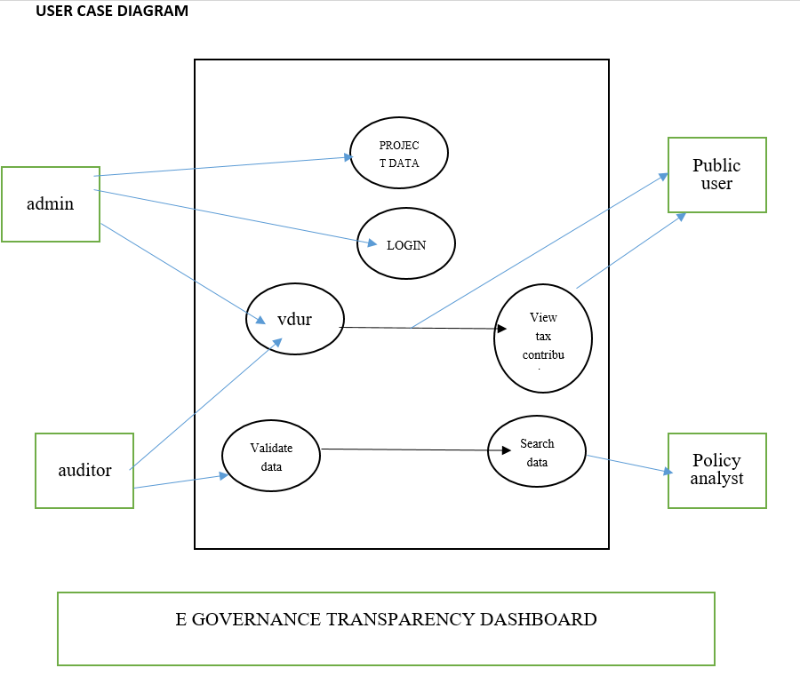

4.1– Manage Project Data
Identifier |  | UC-1
Purpose |  | Enables authorized admin users to create government projects, refresh the information in the system, and close the projects.
Priority |  | High
Pre-conditions |  | Admin is confirmed as a user by the security login.  The department in question or the project ID is available.
Post-conditions |  | The updated data is saved in the main database.  The changes are recorded with date, time, and admin ID for future audits.
Typical Course of Action
S# | Actor Action |  | System Response
1 | Admin logs in |  | The system checks the credentials and opens the admin panel.
2 | Admin clicks on “Add New Project.” |  | The system shows the form for entering project.
3 | Admin inputs the project particulars (budget, department, duration) |  | The system does the validation of input fields.
4 | Admin sends the form. |  | The system keeps the data and displays a message of confirmation.
5 | Admin clicks on “Update Project.” |  | The system fetches the current record for modification.
6 | Admin changes the progress or status. |  | The system modifies the database and generates a log entry.  URL of page: www.mypage.com
Alternate Course of Action
S# | Actor Action |  | System Response
1 | Administrator enters invalid data |  | System displays error message and highlights invalid fields.
2 | Database connection loss |  | System shows failure alert and stores transaction in queue for retry.
Table 1: UC-1
4.2 -View Project and Financial Information
Identifier |  | UC-2
Purpose |  | To enable citizens and researchers to access a summary of information regarding projects and the respective spending, including a detailed report of funding from their tax.
Priority |  | MEDIUM
Pre-conditions |  | The data must have the administrators' approval and be published.  The public user must have an internet-enabled device to access the online service.
Post-conditions |  | The user is able to see the latest project and budget information.  The optional report (in PDF or CSV format) can be generated for download.
Typical Course of Action
S# | Actor Action |  | System Response
1 | User opens dashboard URL |  | System starts displaying the main page along with the search and filter features.
2 | User chooses either department or area. |  | System shows the latest project updates in the list.
3 | user presses “View Details” button |  | System reveals the budget, progress chart, and sources of funding
4 | User goes for "Tax Contribution View ” |  | System presents graphs that show the income tax share of the selected projects.
5 | User report generation (optional) |  | System prepares a file for download and logs usage statistics.
Alternate Course of Action
S# | Actor Action |  | System Response
1 | User enters an invalid keyword in the search bar |  | System replies with "No Results Found."
2 | Server timeout happens |  | System informs of a connection error and advises to try again.

Table 2: UC-2

4.3 – Validate and Audit Data
Identifier |  | UC-3
Purpose |  | To enable auditors to perform data accuracy checks and verify that all changes are properly recorded.
Priority |  | MEDIUM
Pre-conditions |  | The data must have the administrators' approval and be published.  The public user must have an internet-enabled device to access the online service.
Post-conditions |  | The user is able to see the latest project and budget information.  The optional report (in PDF or CSV format) can be generated for download.
Typical Course of Action
S# | Actor Action |  | System Response
1 | AUDITOR SIGNS IN |  | System verifies the credentials.
2 | Auditor goes to “Pending Verifications |  | System shows the latest project updates in the list.
3 | Auditor examines the records |  | System shows the modification history and the associated documents.
4 | Auditor assigns the status of “Verified” or “Flagged.” |  | System changes the verification status and records the time stamp.
Table 3: UC-3
5. Nonfunctional Requirements
Nonfunctional requirements determine the quality levels and system characteristics regarded as necessary to make the E-Governance Transparency Dashboard in a public sector environment to be efficient, secure, and to conduct reliable transactions.
5.1 Performance Requirements
The system shall show the summary dashboards and project data within 3 seconds for normal query loads.
It shall allow 500 users to access public data simultaneously without any impact on performance.
The database should cope with 100,000 project records and their related financial entries without any problem.
The report generation process should take a maximum of 10 seconds for standard departmental or regional reports.
The system's downtime must not exceed 0.5% during working hours, so that the public can always access the system.
The design will incorporate the use of optimized queries and caching to reduce response times and the load on the server to the barest minimum.
5.2 Safety Requirements
Only the authorized administrators will be allowed to change data while the public users will only be granted read access to the data as one way of preventing accidental or malicious changes.
In case of data being corrupted or lost due to a system failure or even a corruption incident, regular backups will ensure that the data is always available.
A trail of the audit will be maintained by the system that captures every data update with the timestamp, user ID and action performed.
Data errors will not occur due to concurrent access or sudden dropping of connections since error-handling mechanisms will be in place.
In the event of a technical failure, the server will automatically switch over and recover according to the set procedures.
5.3 Security Requirements
Client-server communication will utilize HTTPS with SSL/TLS encryption for all sessions.
A different login ID will be assigned to each admin and auditor along with role-based access rights.
The system is going to implement very strict password policies along with regular password renewal.
We'll only encrypt sensitive financial data in the database—nothing else gets that extra protection when it's stored.
To prevent unauthorized access, the system will automatically log out users who haven't been active for a while.
Every login attempt, failed access, and any updates will be recorded in the security logs so we can review them later if needed.
5.4 Additional Software Quality Attributes
Attribute Description / Requirement
Usability The interface will be user-friendly and visually understandable with color-coded indicators and graphs that will facilitate the comprehension of non-technical users.
Reliability The system is expected to have continuous operation with very little downtime; even under high user load, data integrity will be a top priority.
Maintainability The implementation of modular architecture will make it possible for the components (dashboard, reports, authentication) to be updated in a manner that is not dependent on each other.
Scalability The system must support scaling up with the addition of more users and records without any major redesign.
Portability The application will be web-based and will operate on all current browsers and standard server environments without any changes.
Interoperability The platform will be developed with the foresight of being able to connect with outside government databases or APIs in the future.
Accessibility The user interface will be designed in accordance with the WCAG 2.1 accessibility standards so that it can be used by people with disabilities.
Testability All functional modules will be separately testable, which means that performance, accuracy, and security criteria will be checked through a very dependable process.
Availability The system is going to be available and operational at least 24/7 with prior notification of scheduled maintenance areas.
Flexibility The structure will grant the easy incorporation of additional modules (for example, new financial data sources or regional dashboards) with minimal difficulty.
6. Other Requirements
This part of the document describes the extra conditions of the E-Governance Transparency Dashboard which are not explicitly mentioned in the functional or non-functional requirements. These requirements represent the constraints, interfaces, and external considerations that will support the system's operation and future growth
6.1 Database Requirements
The use of a centralized relational database for storing project, financial, tax summary, user, and audit-related information is a requirement of the system.
Data integrity must be assured by the database with the help of primary and foreign key constraints, whereas the database must also enforce having consistency between the records that are related.
The database is to be backed up regularly in order to prevent loss of data should the system fail.
The system is responsible for the long-term storage of data without reducing performance in any way, as the number of projects, departments, and financial records is expected to grow significantly. Access to the database will be strictly limited to authorized system components and users only.
6.2 External Interface Requirements
6.2.1 User Interface
The system will include a web-based graphical user interface that can be accessed from standard web browsers.
The interface should be able to present dashboards, charts, and reports in a manner that is easy and visually understandable to non-technical users.
Public users will not be required to login in order to see the information that has been made public, while administrative and audit functions will require secure authentication.
6.2.2 Software Interface
The architecture of the system will be such that it will be possible to integrate it with external government systems in the future, such as financial management tools, statistical platforms, or geographic information systems.
It is possible that Application Programming Interfaces (APIs) could be used in later phases to allow authorized external systems to perform controlled data exchanges with the system.
6.2.3 Communication Interface
In order to guarantee confidentiality and data security, all communication between clients and servers will proceed through secure HTTPS connections.

6.3 Hardware Requirements
A server that is capable of public access and administrative operations simultaneous management will be the hosting site for the system.
On the client side, it can simply be a standard computing device, which may be a desktop, laptop, tablet, or smartphone, along with internet access. No additional hardware is needed for the users besides the normal devices that are internet-enabled.

6.4 Software Requirements

The system shall be compatible to run on server operating systems that are widely-used such as Windows Server and hard drives with Linux-based software.
The database management system could be MySQL. SQL or an equivalent relational database solution. The program will also be compatible with modern web browsers such as Chrome, Firefox, and Edge. The server software will be able to authenticate users securely, process data, and generate reports.

6.5 Legal and Regulatory Requirements

The system would conform to the requirements of those laws that regulate the public's right to access information and that promote transparency in the government. Public access will be restricted, the budget data will be available in aggregate, while personal or sensitive financial information will be kept hidden.
The system will keep log files containing detailed records of user activities and access to documents for the purpose of meeting accountability and compliance standards. the system shall respect the data protection principles that guarantee the lawful, fair, and responsible handling of information.

6.6 Reuse Objectives and Future Expansion
Modular design is the key to the system architecture that lets the core parts be reused like authorization, reporting, and visualization modules.
The system shall be designed in such a way that there will be no need for a complete redesign when the platform comes to support the future expansion which may consist of adding more departments, regions, or financial indicators. The decision-making and policy evaluation process can be further improved through the incorporation of new analytical modules or data sources in the later phases.

7.DESIGNING
7.1 CLASS DIAGRAM
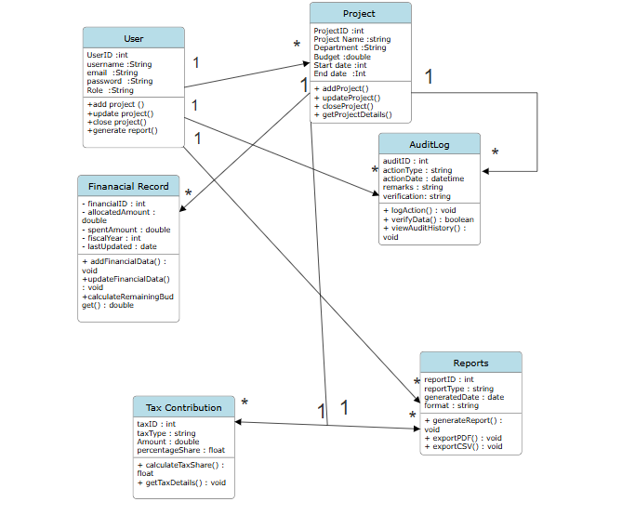

7.2
Context level DFD
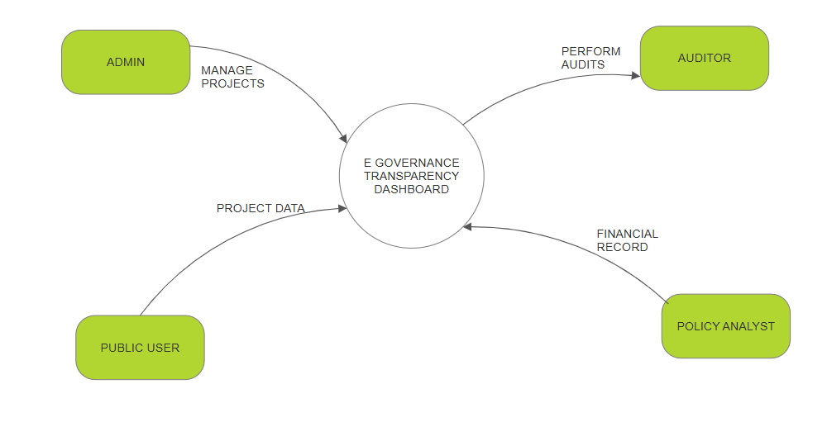Level 1- dfd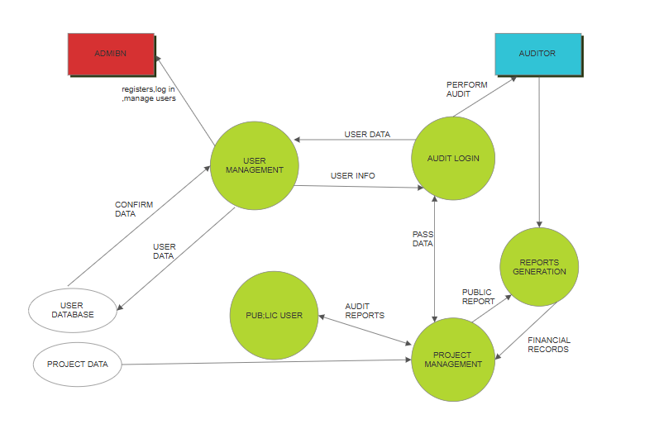

7.3 ERD
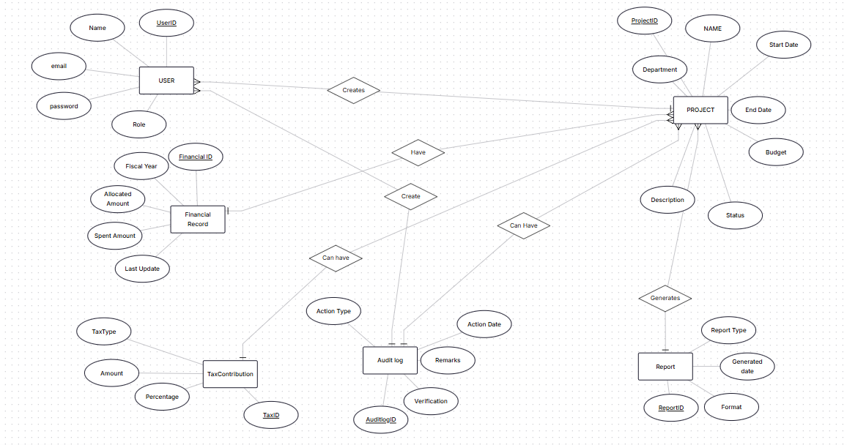

7.4 PHYSICAL DESIGN
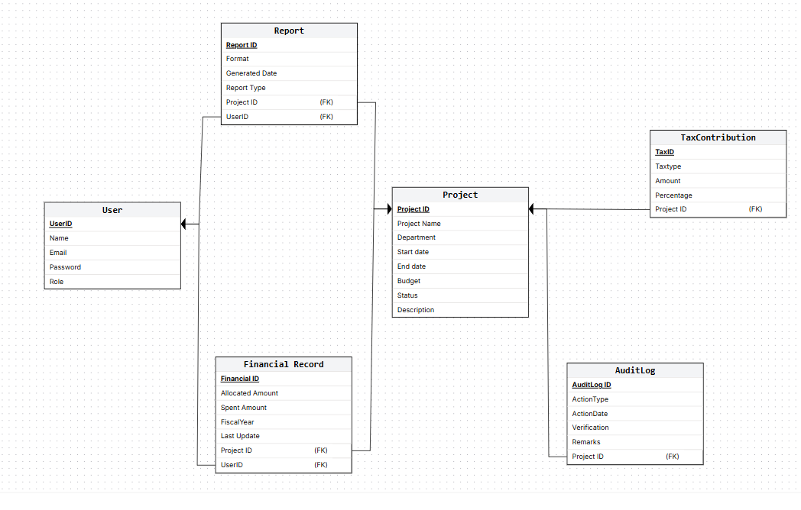

7.5 user design
1. Model–View–Controller (MVC) Pattern

Objective:
To partition business logic, user interface, and data management.
Usage in System:
Model:
Project, Financial Record, User, Audit Log
View:
Dashboard Interface, Project Detail View, Report View
Controller:
Project Controller, Finance Controller, Report Controller, Authentication Controller
Justification:
MVC enhances maintainability by separating data manipulation from its visual representation. It permits changes in the user interface without impacting the underlying functionality and caters to different user roles (Admin, Public User, Auditor).
2. Singleton Pattern
Objective:
To have just one instance of a critical service throughout the application.
Usage in System:
Connection to the Database, Logging of Audits
Justification:
It stops the creation of multiple connections to the database and ensures that all the system’s activities are logged in a central manner, which is very important for audit and compliance purposes.
3. Role-Based Access Control (RBAC) Pattern
Objective:
To allow for access to the system that is proportionate to user roles.
Usage in System:
User, Role, Permission
Justification:
Admins can change data, Auditors can review and evaluate, Public users have read-only access. This aligns with the security and safety requirements outlined in Chapter 5.
4. Observer Pattern
Purpose:
To automatically notify all concerned components when data changes.
Application in System:
Project, FinancialRecord, AuditLog
Reason for Use:
Whenever project or financial data is updated, audit logs and dashboards are automatically refreshed. This maintains data consistency and provides real-time visibility.

5. Factory Pattern
Purpose:
To create objects without exposing the creation logic.
Application in System:
ReportFactory, PDFReport, CSVReport
Reason for Use:
It supports extensibility of report formats without modifying existing code and allows new report types to be added easily in the future.
Summary
The application of design patterns ensures that the system is modular, secure, scalable, and easy to maintain. These patterns directly support both functional and non-functional requirements and align with the system models developed in earlier chapters.

7.6 scenario 1
Sequence diagram
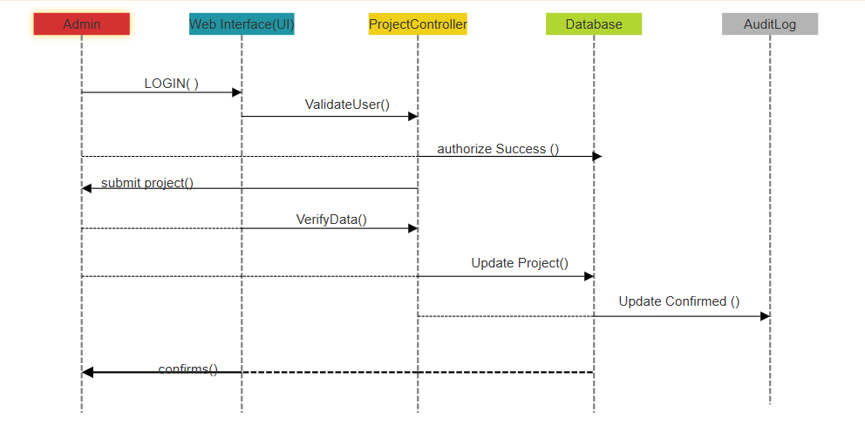
Collaboration diagram
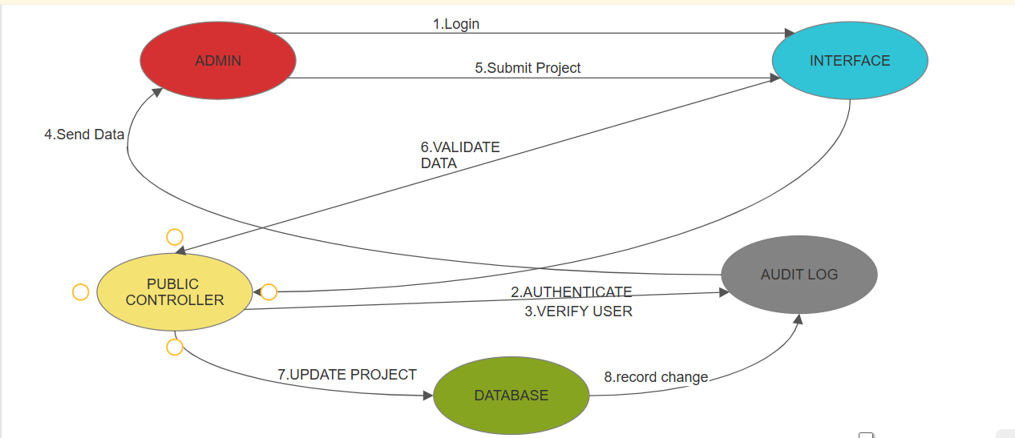

7.6 scenario 2
Sequence diagram
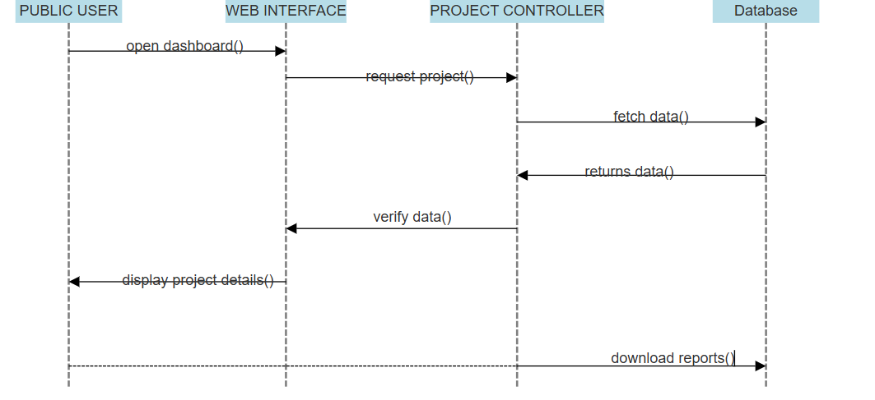

Collaboration diagram

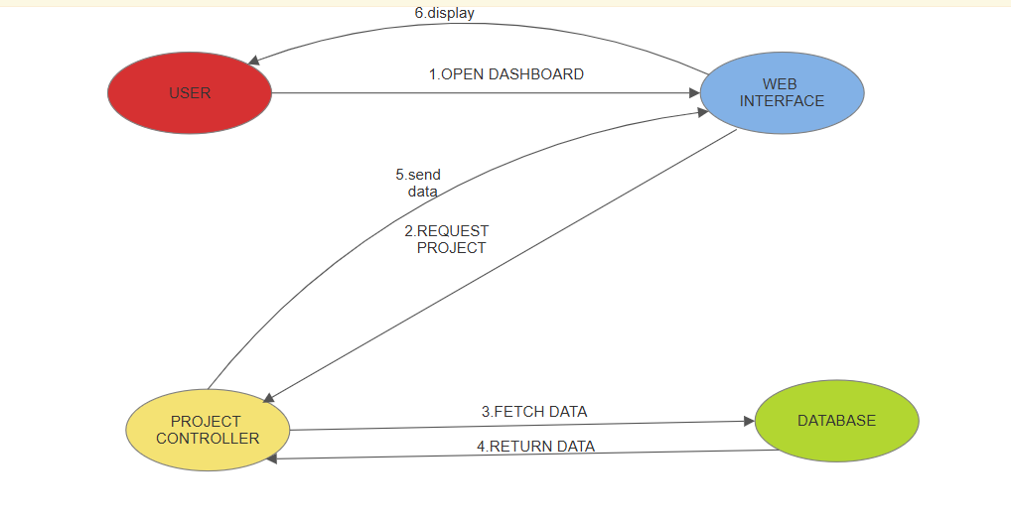
8. Estimation
This chapter provides an approximate estimation of cost, benefits, and development effort for the proposed E-Governance Transparency Dashboard. The estimations are based on reasonable assumptions considering the system scope, functionality, and public-sector nature.
8.1 Cost Benefit Estimation
The cost–benefit analysis evaluates whether the proposed system is economically feasible by comparing the expected benefits against the estimated development and operational costs.
Estimated Costs (1st Year)
Cost Component | Estimated Cost (USD)
System Development | 12,000
Server & Hosting | 3,000
Database & Software Tools | 2,000
Maintenance & Support | 3,000
Total Estimated Cost | 20,000

Estimated Benefits (1st Year)
Benefit Component | Estimated Value (USD)
Reduced Manual Reporting | 10,000
Improved Transparency & Trust | 8,000
Time Savings for Officials | 7,000
Reduced Audit & Compliance Costs | 5,000
Total Estimated Benefits | 30,000

8.1.1 Return on Investment (ROI) – 1st Year
Formula:
ROI = Benefits / Cost
Calculation:
ROI = 30,000 / 20,000
ROI = 1.5
8.1.2 Percentage Gain on ROI – 1st Year
Formula:
% Gain on ROI = {(Benefits − Cost) / Cost} × 100
Calculation:
% Gain = {(30,000 − 20,000) / 20,000} × 100
% Gain on ROI = 50%

8.1.3 Payback Period (in years)
Formula:
Payback Period = Cost / Benefit
Calculation:
Payback Period = 20,000 / 30,000
Payback Period = 0.67 years
The system is expected to recover its cost in less than one year.

8.2 Function Point (FP) Based Estimation
Function Point estimation is used to estimate system size based on functionality visible to users.
Function Point Components
Component | Count
External Inputs (EI) | 10
External Outputs (EO) | 8
External Inquiries (EQ) | 6
Internal Logical Files (ILF) | 5
External Interface Files (EIF) | 2
Weighted FP Calculation (Approx.)
Using standard average weights:
Component | Count | Weight | Total
EI | 10 | 4 | 40
EO | 8 | 5 | 40
EQ | 6 | 4 | 24
ILF | 5 | 10 | 50
EIF | 2 | 7 | 14
Total Function Points (FP) |  |  | 168 FP

8.3 COCOMO Estimation (FP-Based)
The COCOMO model is used to estimate development effort based on the system size.
Step 1: Convert FP to KLOC
Assuming:
1 FP ≈ 50 Lines of Code
LOC = 168 × 50 = 8,400 LOC
KLOC = 8.4

Step 2: Apply Basic COCOMO (Organic Mode)
Formula:
Effort = 2.4 × (KLOC)^1.05
Calculation:
Effort = 2.4 × (8.4)^1.05
Effort ≈ 21 Person-Months
Development Time Estimation
Formula:
Time = 2.5 × (Effort)^0.38
Calculation:
Time ≈ 2.5 × (21)^0.38
Development Time ≈ 6 months

